Walking Directions
- This route starts outside Visit York.
- Turn left onto Museum Street and follow it down towards the river.
- At the gates to the Museum Gardens, head down the hill next to Lendal Bridge.
- Turn right at the end onto the riverside path and keep following the river, on your left.
- At Clifton Bridge, follow the hill up on to the road.
- Turn left and cross over Clifton Bridge.
- After the bridge, you will see the path down to the opposite river bank.
- Follow the riverside path, keeping the river on your left.
- Once you pass York City Rowing Club, on your right, head up the ramp or steps onto Lendal Bridge.
- Cross Lendal Bridge and follow the road towards York Minster.
- Please note: During flooding, this pathway is inaccessible.
- This route is not wheelchair and pushchair accessible from Clifton Bridge onwards.
Scan this QR code to see the walk on your mobile device.
- Please be aware the pathway can be muddy after rainfall, especially on the way back into York.
Photo Credit: Google Maps

Map of Walking Route

Photo Credit: Google Maps
What to look out for
- Walk along Dame Judi Dench Walk, named after the York actress.
- See the variety of wildlife along the River Ouse.
- Look out for boats and rowers going along the river.
- See the view of York Minster on your way back into the centre.

Photos
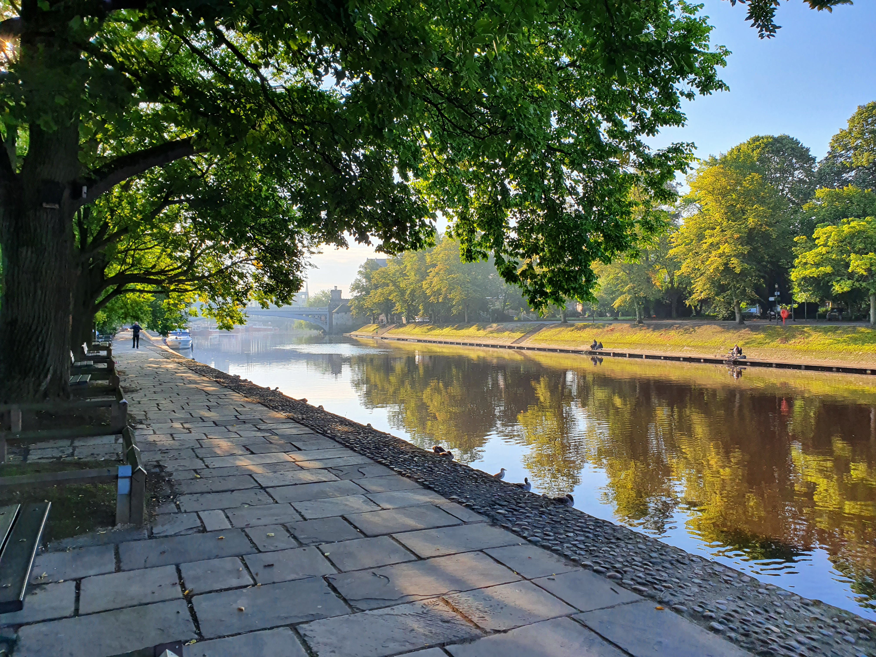
View from near Marygate Photo Credit: JU

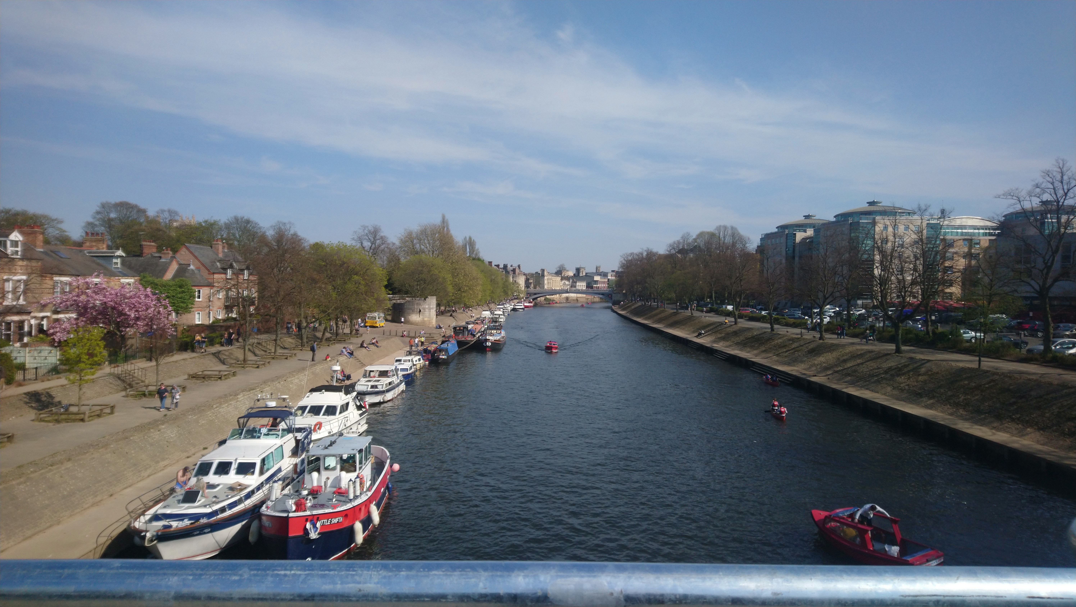
View from Scarborough Bridge Photo Credit: JU

York Minster from Precentor’s Court Photo Credit: JU

Walks around York
2
Circular route north along the river from Visit York
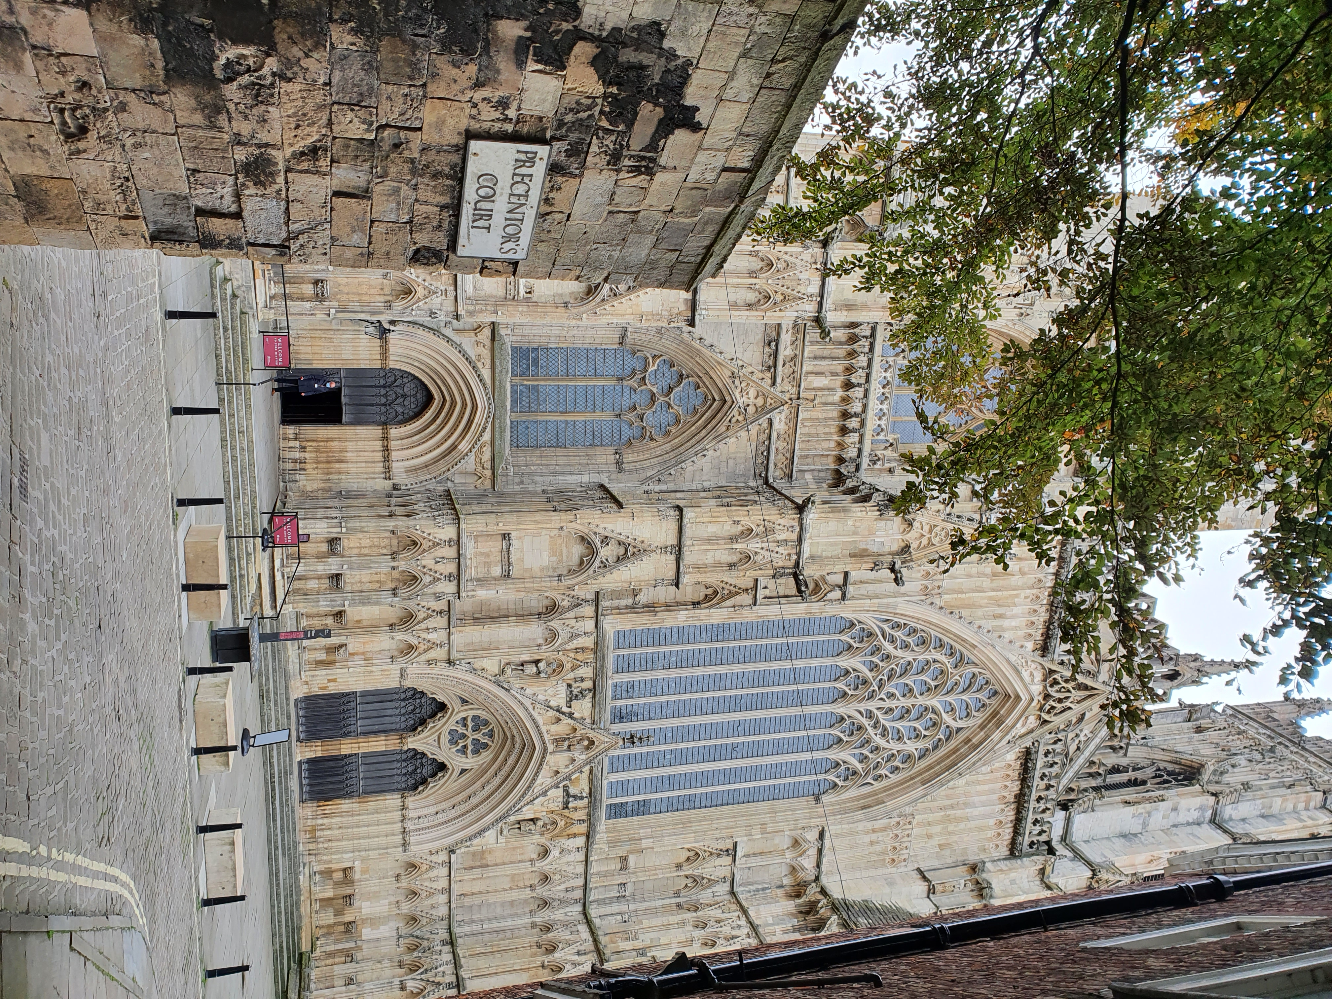50 Minutes / 2.4 Miles (3.9 km)

As of March 2021
Please check before travelling

