Walking Directions
- This route starts outside Visit York.
- Turn left onto Museum Street and follow it down towards the river.
- At the gates to the Museum Gardens, head down the hill next to Lendal Bridge.
- Turn right at the end onto the riverside path and keep following the river, on your left.
- Head under Clifton Bridge and keep following the embankment along the river.
- Continue following the embankment and the river as you pass Riverside Farm Pub.
- Between the pub and before the railway bridge, take the path away from the river through the trees.
- Continue following this path until you reach Stripe Lane.
- Turn right onto Stripe Lane and follow it to the junction with the A19 at Skelton.
- Carefully cross the A19 using the crossing to reach the bus stop to go back to York.
- Please note: During flooding, this pathway is inaccessible.
- This route is not wheelchair and pushchair accessible from Clifton Bridge onwards.
- Please be aware the pathway can be muddy after rainfall.
Photo Credit: Google Maps
Scan this QR code to see the walk on your mobile device.
Map of Walking Route

What to look out for
- Walk along Dame Judi Dench Walk, named after the York actress.
- See the variety of wildlife along the River Ouse.
- Look out for boats and rowers going along the river.
Optional Diversions
- Instead of turning off towards Skelton, you can continue along the riverside path for a further 5.6 miles (9km) to Newton on Ouse.
- Please note there is a very limited bus service from Newton on Ouse to York.
Getting the bus back to York
- At Skelton, buses run around every hour Monday to Saturday back to York.
View from Scarborough Bridge Photo Credit: JU
- Please check www.reliancebuses.co.uk for further information.

Photos
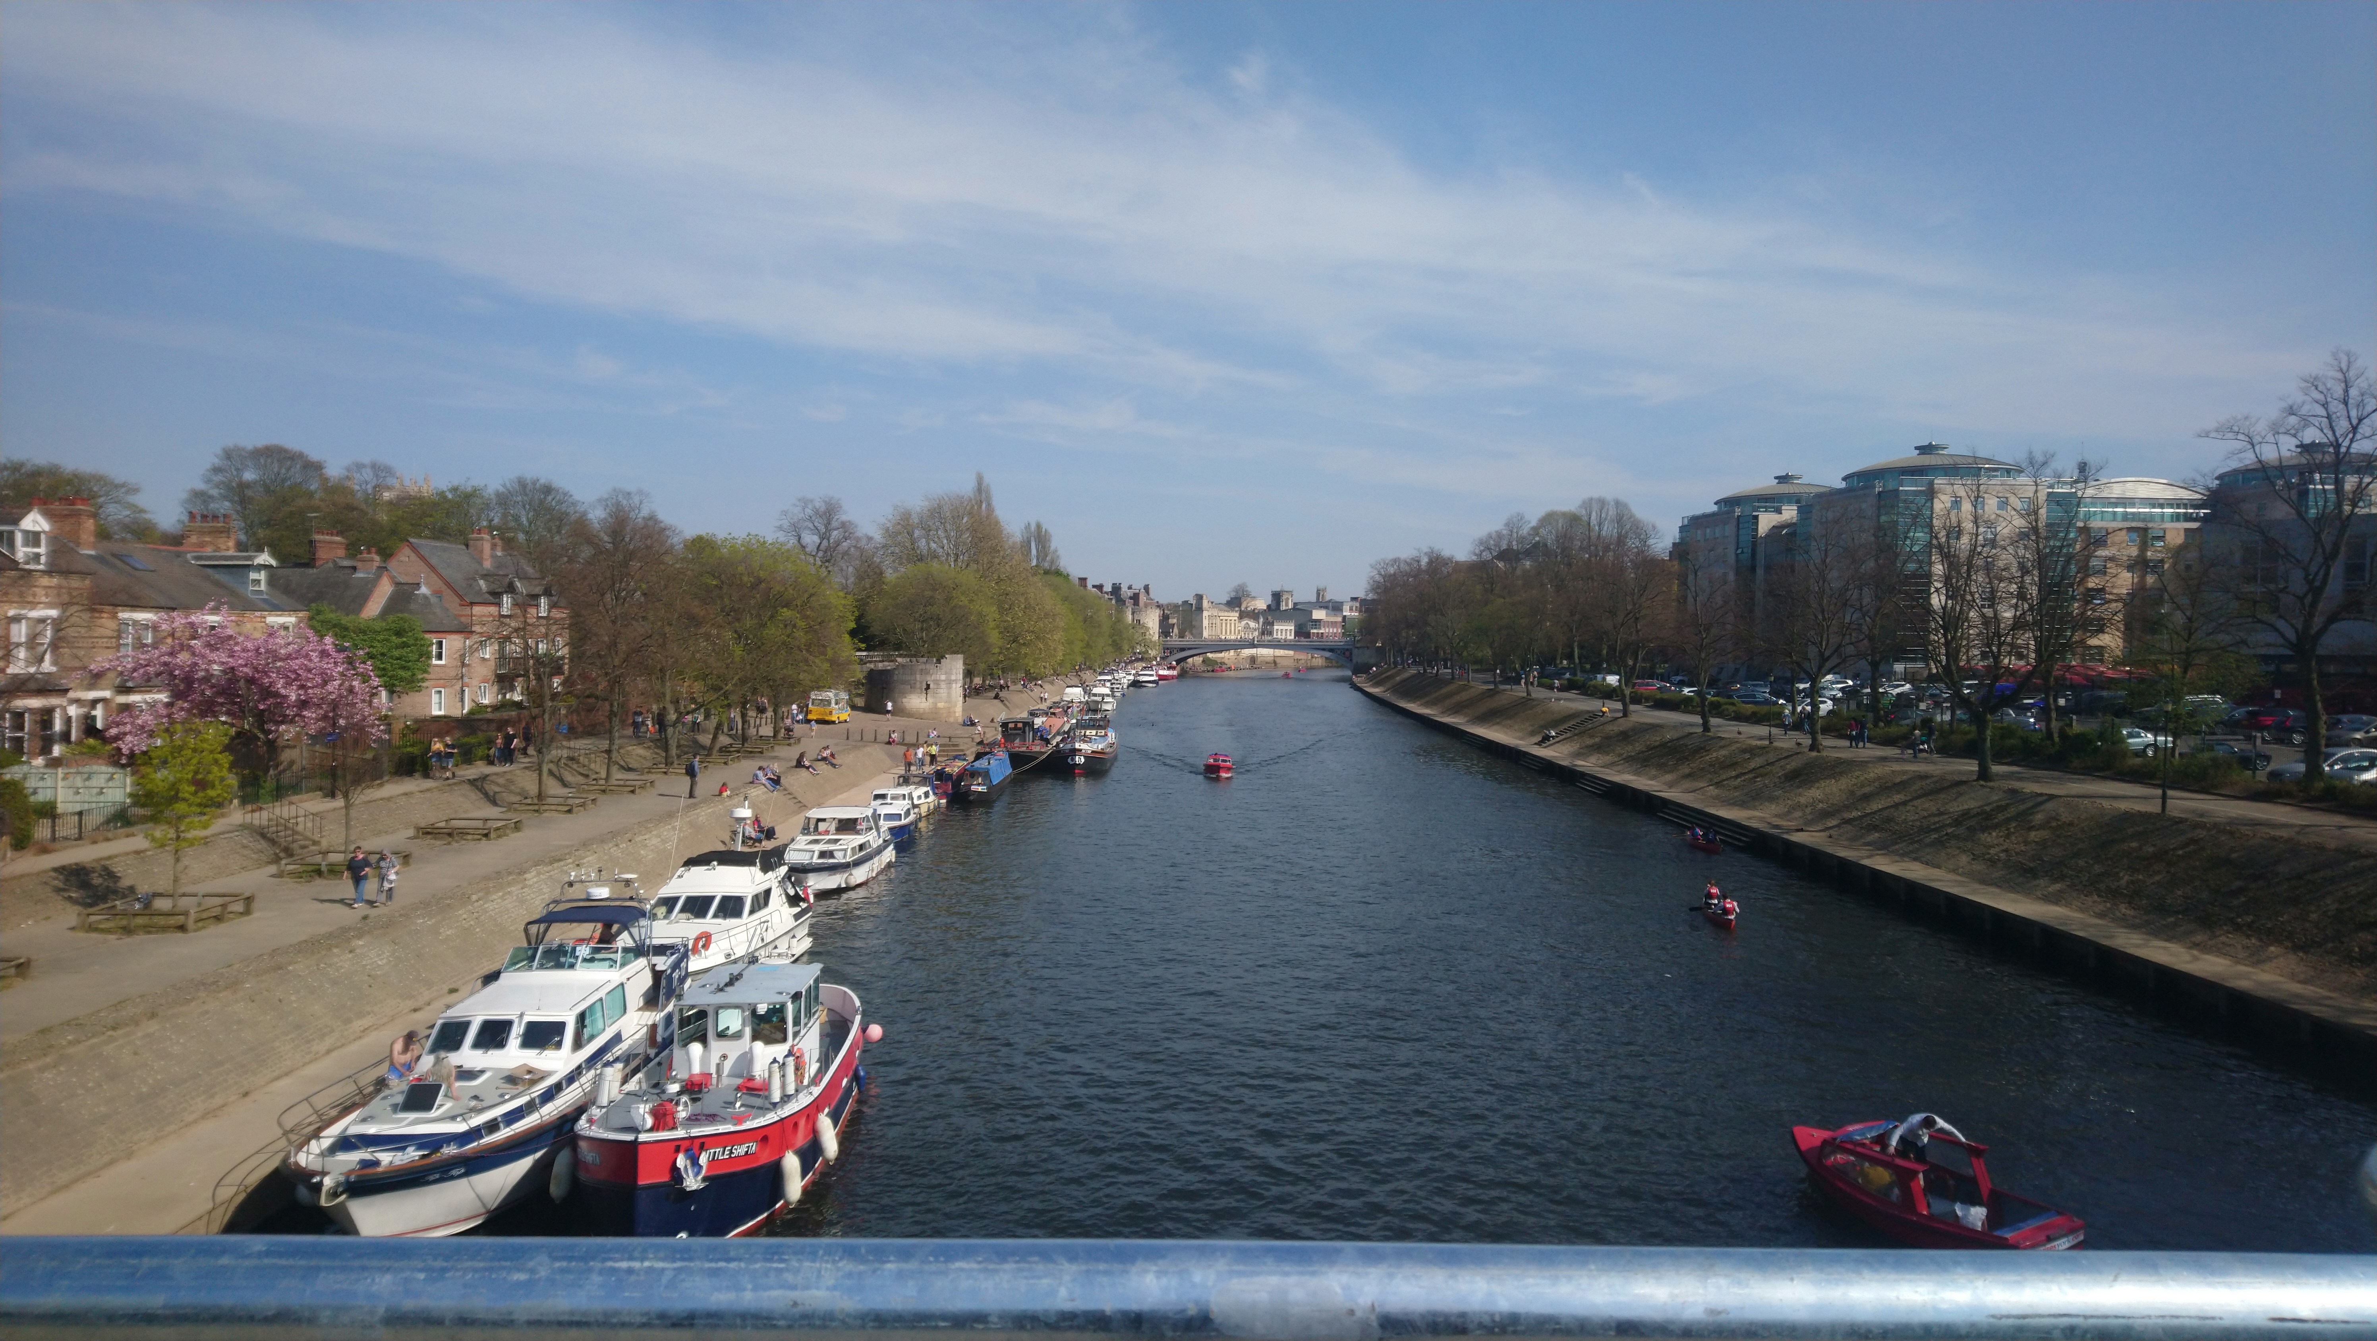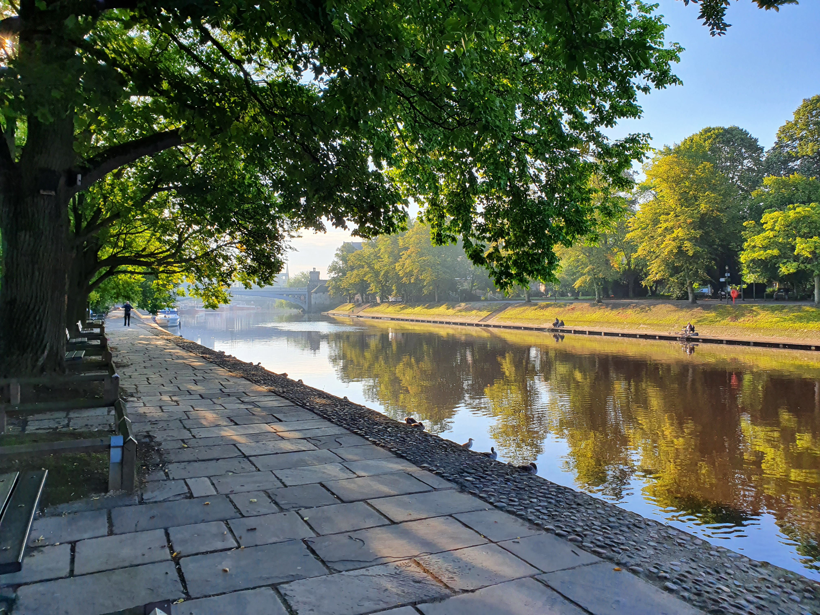
View from near Marygate Photo Credit: JU

York Minster from Precentor’s Court Photo Credit: JU

Walks around York
6
North along the river to Skelton from Visit York
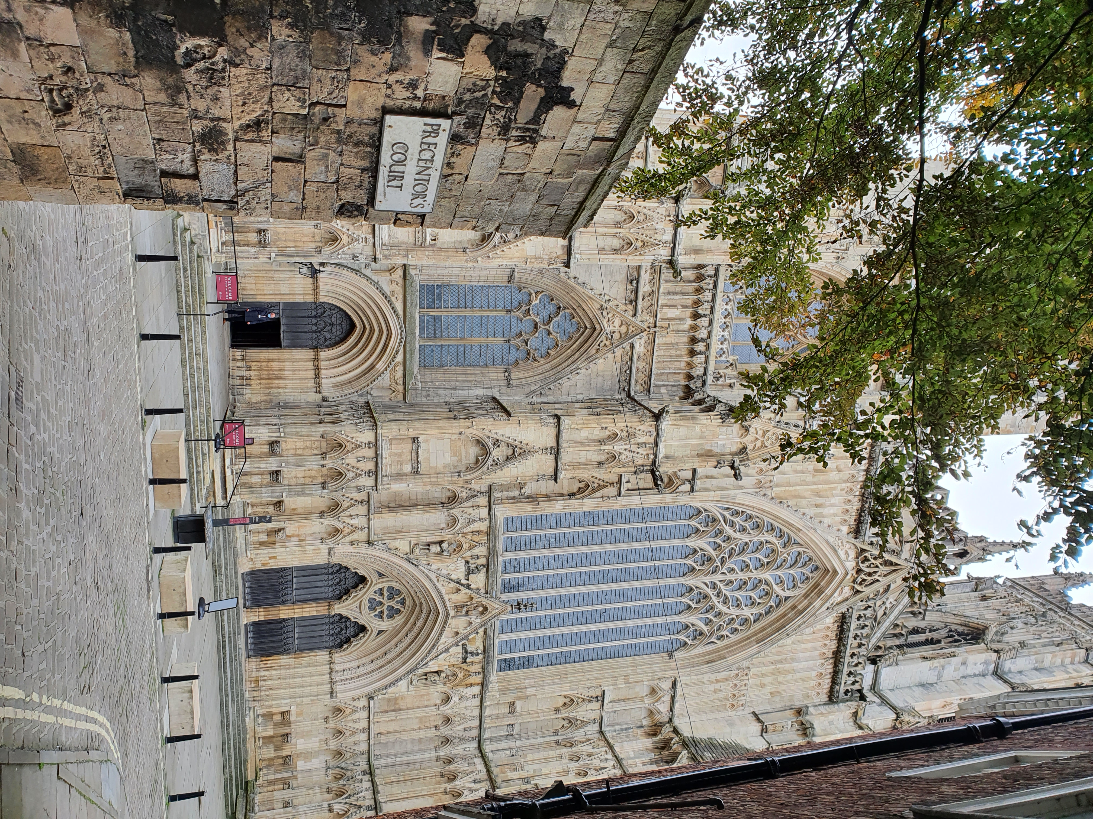1 hour 30 Minutes / 4.3 Miles (7 km)

As of 17th October 2020
Please check before travelling

