Suggested Walking Route
- Start outside Visit York, go straight across the road and follow the crescent around to Bootham Bar. Here you can also catch the Sightseeing Buses.
- Head up the steps onto the city walls and follow the walls around.
- Leave the city walls at Monk Bar and head down Goodramgate, home to cafés, shops & pubs. Pass Lady’s Row and Holy Trinity Church, on your right.
- At King’s Square pass Chocolate Story and head down the historic Shambles.
- At the bottom, turn right onto Pavement and follow the road, keeping All Saints Church on your right.
- Turn left into the Coppergate Centre, passing Jorvik and Van Gogh Expo.
- Pass through the archway to the right of Fenwick’s and past Fairfax House to see Clifford’s Tower and Castle Museum.
- Head along Tower Street, passing York Army Museum and turn right onto Clifford Street, past York Dungeon on your left.
- Keep following the road straight on to Coney Street for all the big high street shops and straight across the square onto Lendal.
This guide just shows you the highlights but there is much more to see if you have time. Visit our website at www.visityork.org or ask one of our friendly staff, who are happy to help you plan your day.

- At the top of Lendal, head straight forward for Museum Gardens or down the cobbled hill for City Cruises. Turn right here for Visit York, where you started.
Map of Walking Route
Photo Credit: Google Maps
Scan this QR code to see the walk on your mobile device.
Optional diversions off the suggested route
If the city walls are closed (step 2), at Bootham Bar, head through the arch and onto High Petergate.
At the Minster, head left around the side on Deangate – this takes you to College Green for picturesque cafes and then straight onto Goodramgate. Turn right to continue the route from step 3.
Along Coney Street (step 9), turn right at St Helen’s Square to see Betty’s Tearoom and the Mansion House. Head straight forward onto Stonegate for lovely shops.
York Minster from the City Walls Photo Credit: JU
Prefer a guided tour?
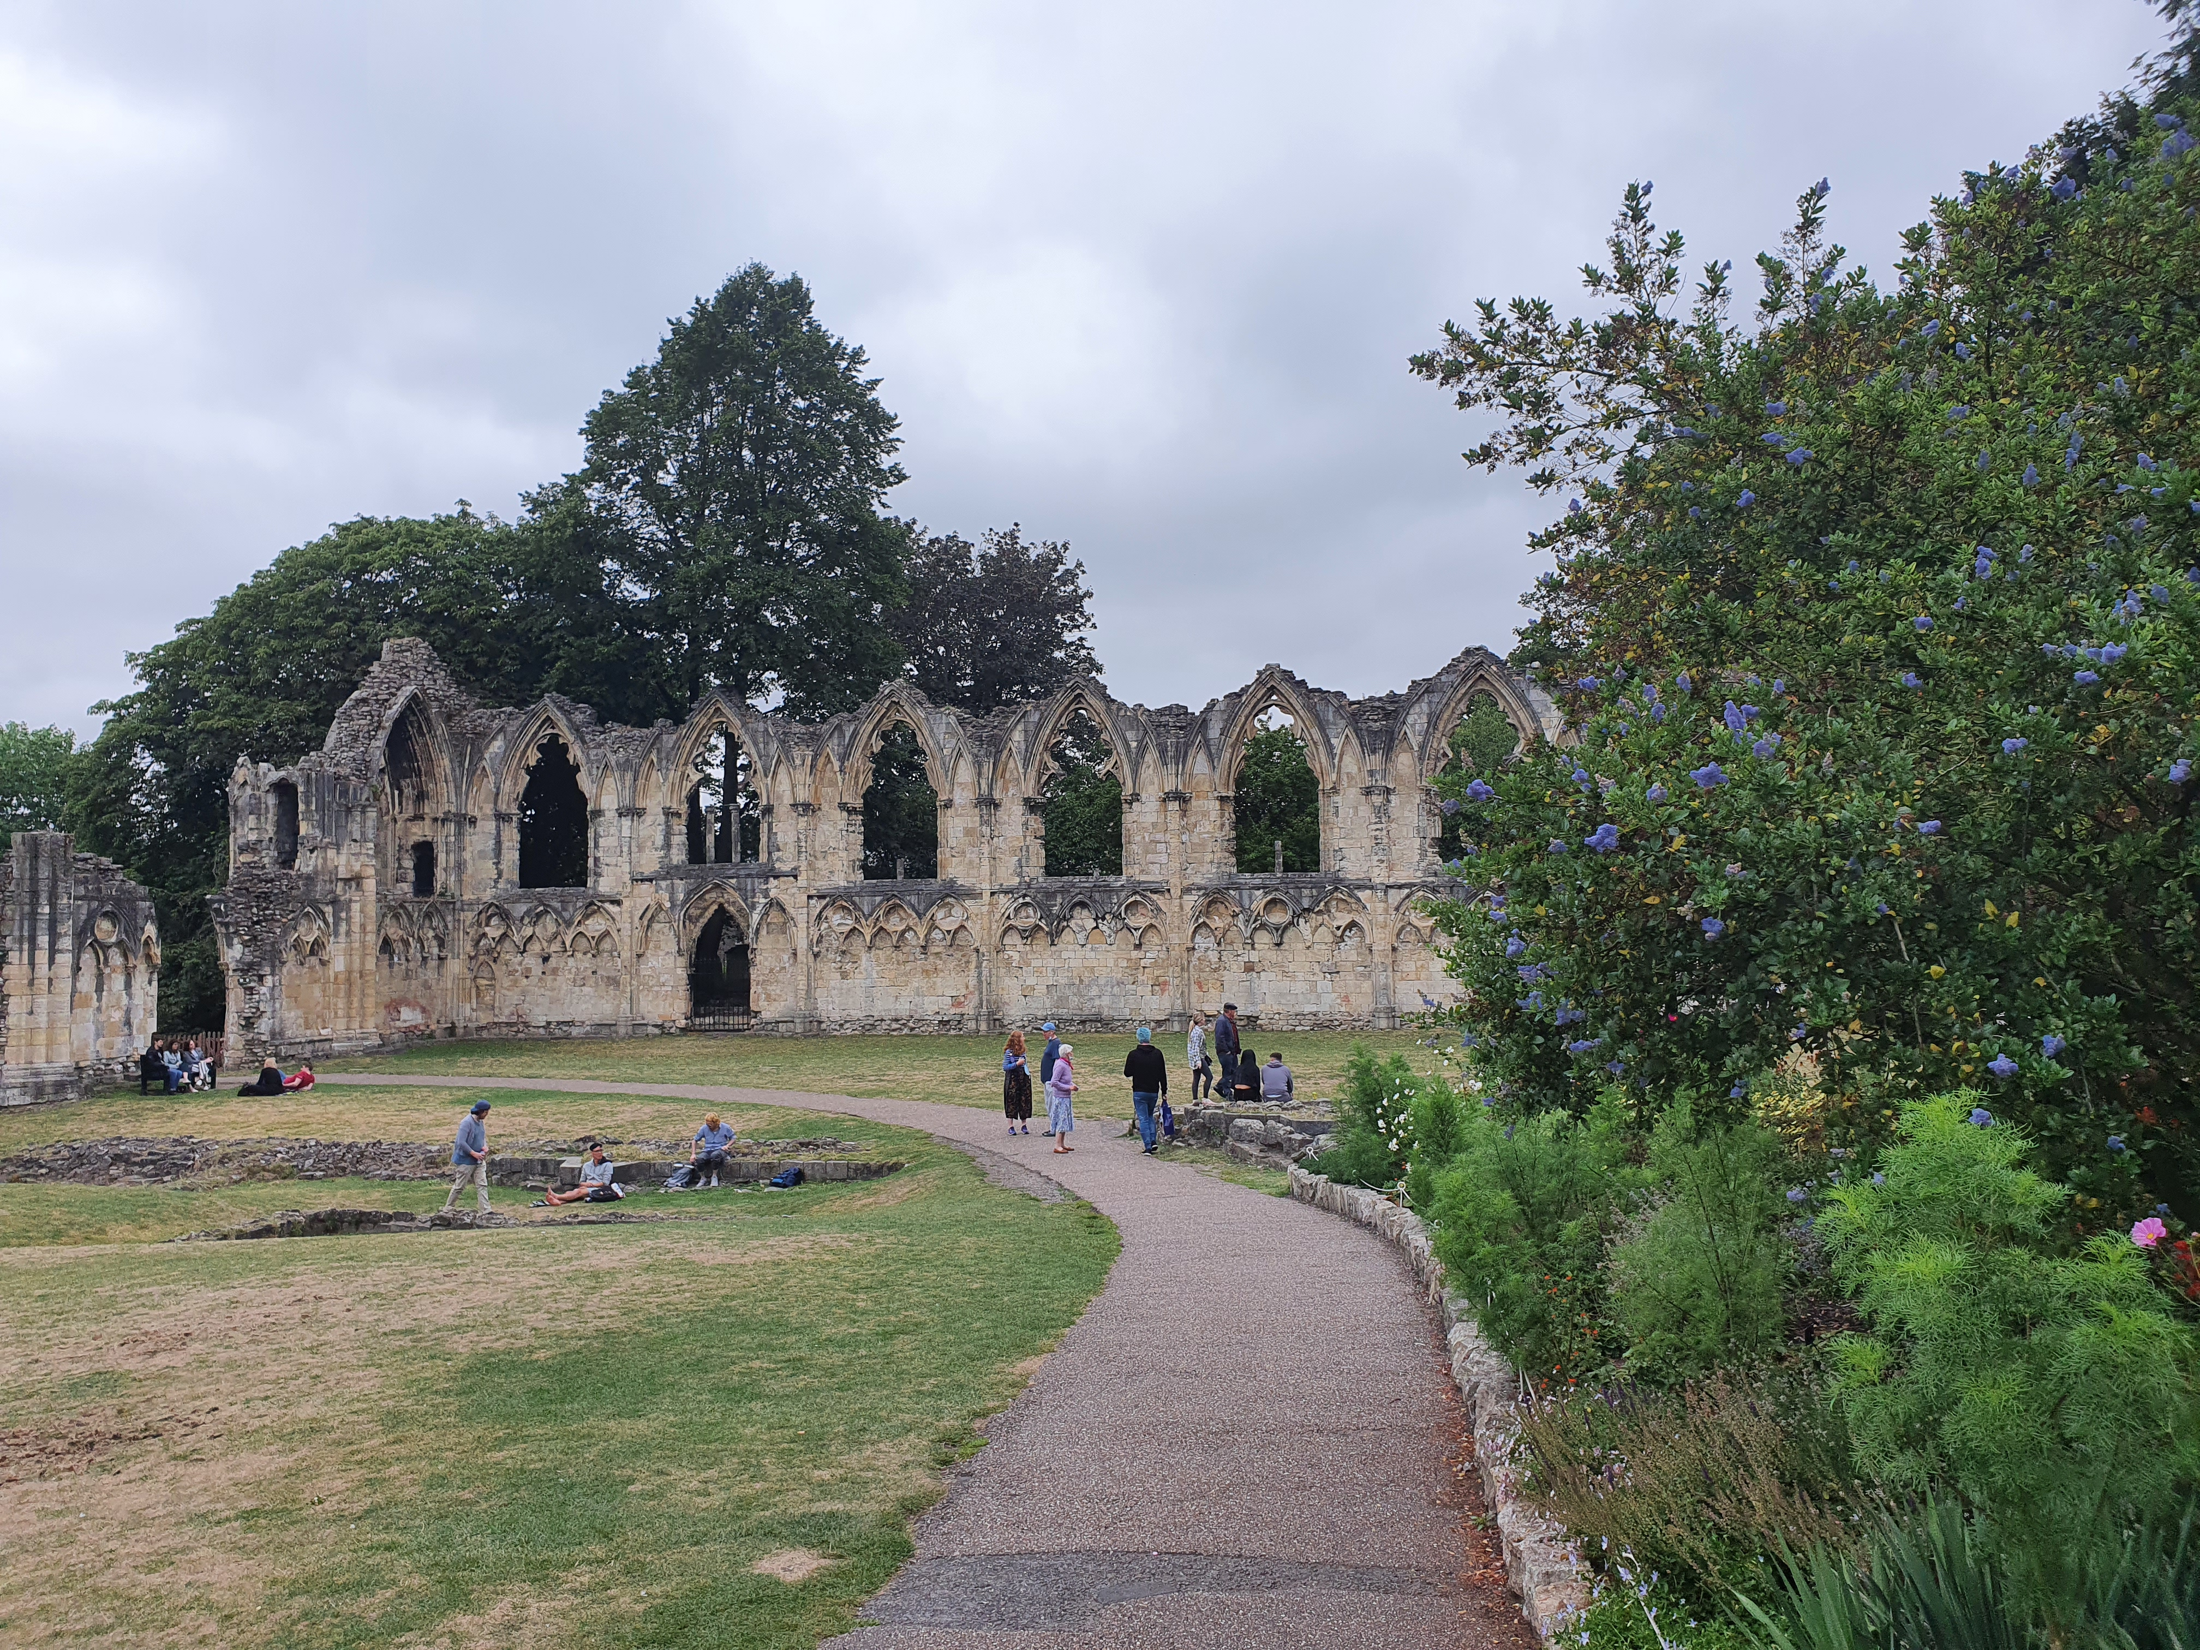Ask one of our friendly staff for leaflets on guided walking tours of the city. We also sell tickets for the City Cruises Boat and the Sightseeing Buses.
Enjoyed York and want to visit again in the future?
Why not consider the York Pass which gives you access to attractions in York and the surrounding area. Visit www.yorkpass.com or ask one of our friendly staff for further details.
St Mary’s Abbey in the Museum Gardens Photo Credit: JU
What to see on the route
- 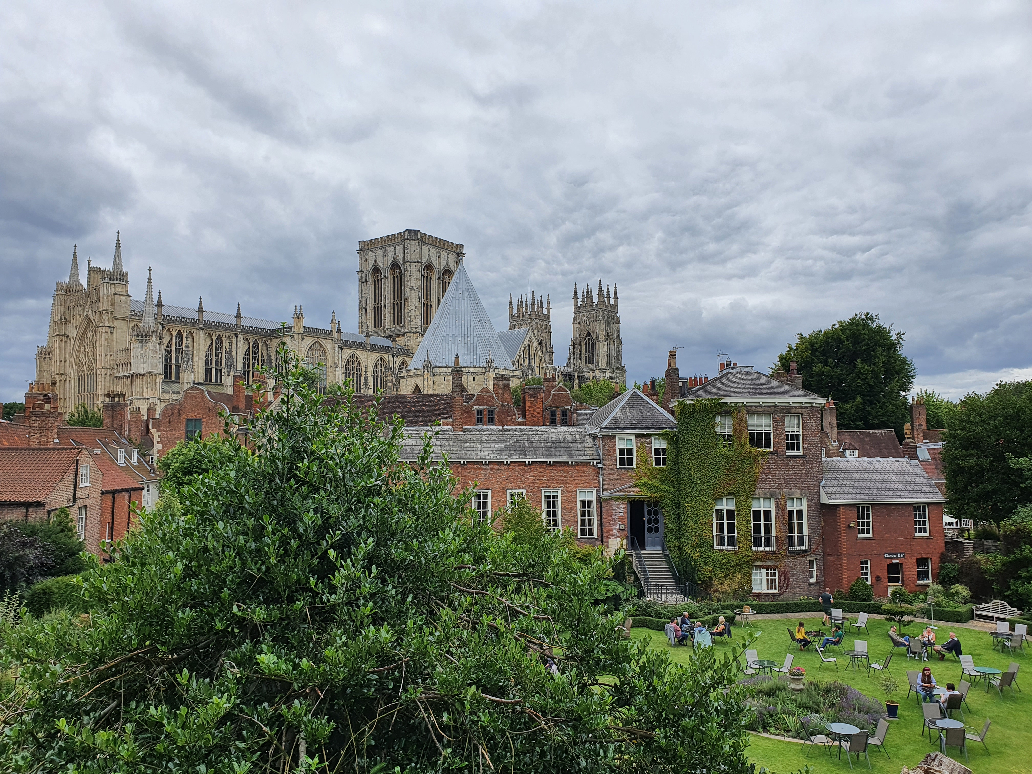As you follow the City Walls, look to your right to see a view over York Minster behind Gray’s Court.
- In the Museum Gardens, look out for the ruins of St Mary’s Abbey and Multangular Tower. Also see if you can spot the squirrels that roam around the gardens.
Walks around York
1
Whistle Stop Tour, including a suggested walking route
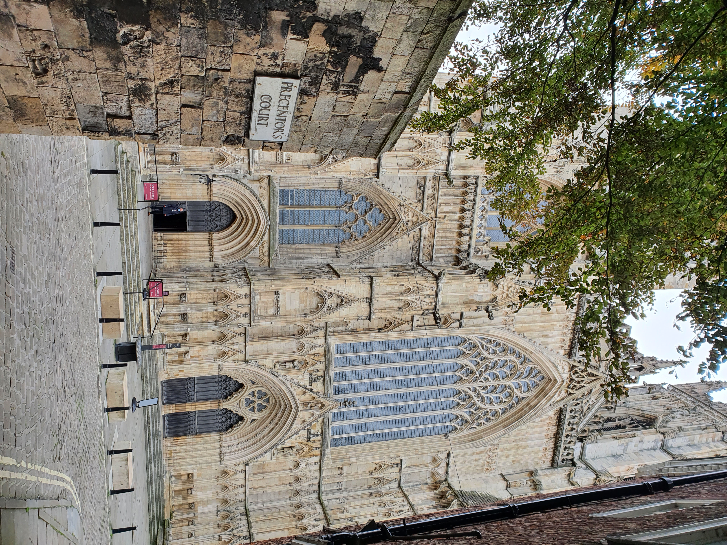40 Minutes / 2 Miles (3.2km)

As of March 2021
Please check before travelling

