Walking Directions
- This route starts outside Clifford’s Tower
- Cross over Tower Street using the pedestrian crossing, head through the gardens and turn left onto the riverside path.
- Follow the riverside path along, crossing over the River Foss at Blue Bridge.
- Continue following the riverside path (New Walk) until you reach Millennium Bridge.
- Due to flood works, the riverside path is closed from Roomzzz Hotel until Skeldergate Bridge.
- To continue, cross Millennium Bridge, go past Rowntree Park on your right, and go straight ahead onto Butcher Terrace.
- At the end, turn right onto Bishopthorpe Road. There are lots of independent shops and cafes along here to visit.
- Follow the road onto Bishopgate Street, keeping the City Walls on your left.
- At Skeldergate Bridge head onto the bridge and over the river, using the crossing.
- At the roundabout, turn left onto Tower Street and you will see Clifford’s Tower ahead of you.
- Please note: During flooding, this pathway is inaccessible
- This route is wheelchair and pushchair accessible but please be aware the pathway can be muddy after rainfall.
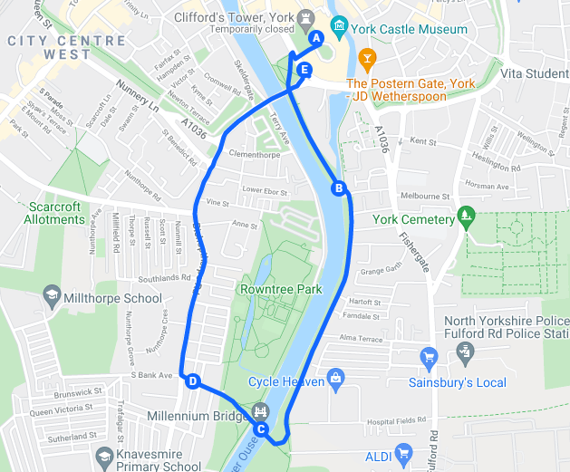
Map of Walking Route

Scan this QR code to see the walk on your mobile device.
Photo Credit: Google Maps
What to look out for
- Walk along New Walk, a tree lined avenue created in the 1730’s.
- Look out for the old Terry’s Chocolate Factory in the distance.
- Cross York’s Millennium Bridge, opened in 2001.
- Explore Rowntree’s Park, a large green space with playgrounds and a lake. Opening times vary.
- Due to the flood works, to access Rowntree Park, turn right at the end of Millennium Bridge, along the riverside. The entrance is on the left. To continue the walk, go through the gardens and over the bridge past the café. This takes you onto Richardson Street, at the top turn right onto Bishopthorpe Road then carry onto Bishopgate Street.

View from New Walk Photo Credit: JU
How to get there
On Foot
- Clifford’s Tower is located to the south of the city centre, just off Tower Street.
- From the Visit York office, turn right onto Blake Street and follow the road down.
- At the bottom of Parliament Street, turn right onto Coppergate.
- After a short distance turn left into Castlegate.
- Continue straight around the side of Clifford’s Tower until you are stood at the bottom of the steps up the mound.
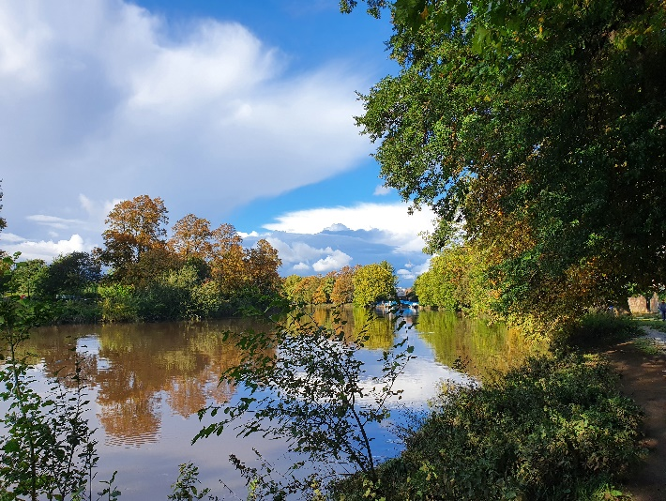
- You are ready to start the walk!
York Minster from Precentor’s Court Photo Credit: JU
Walks around York
3
York Minster from Precentor’s Court Photo Credit: JU
Circular route south along the river from Clifford’s Tower
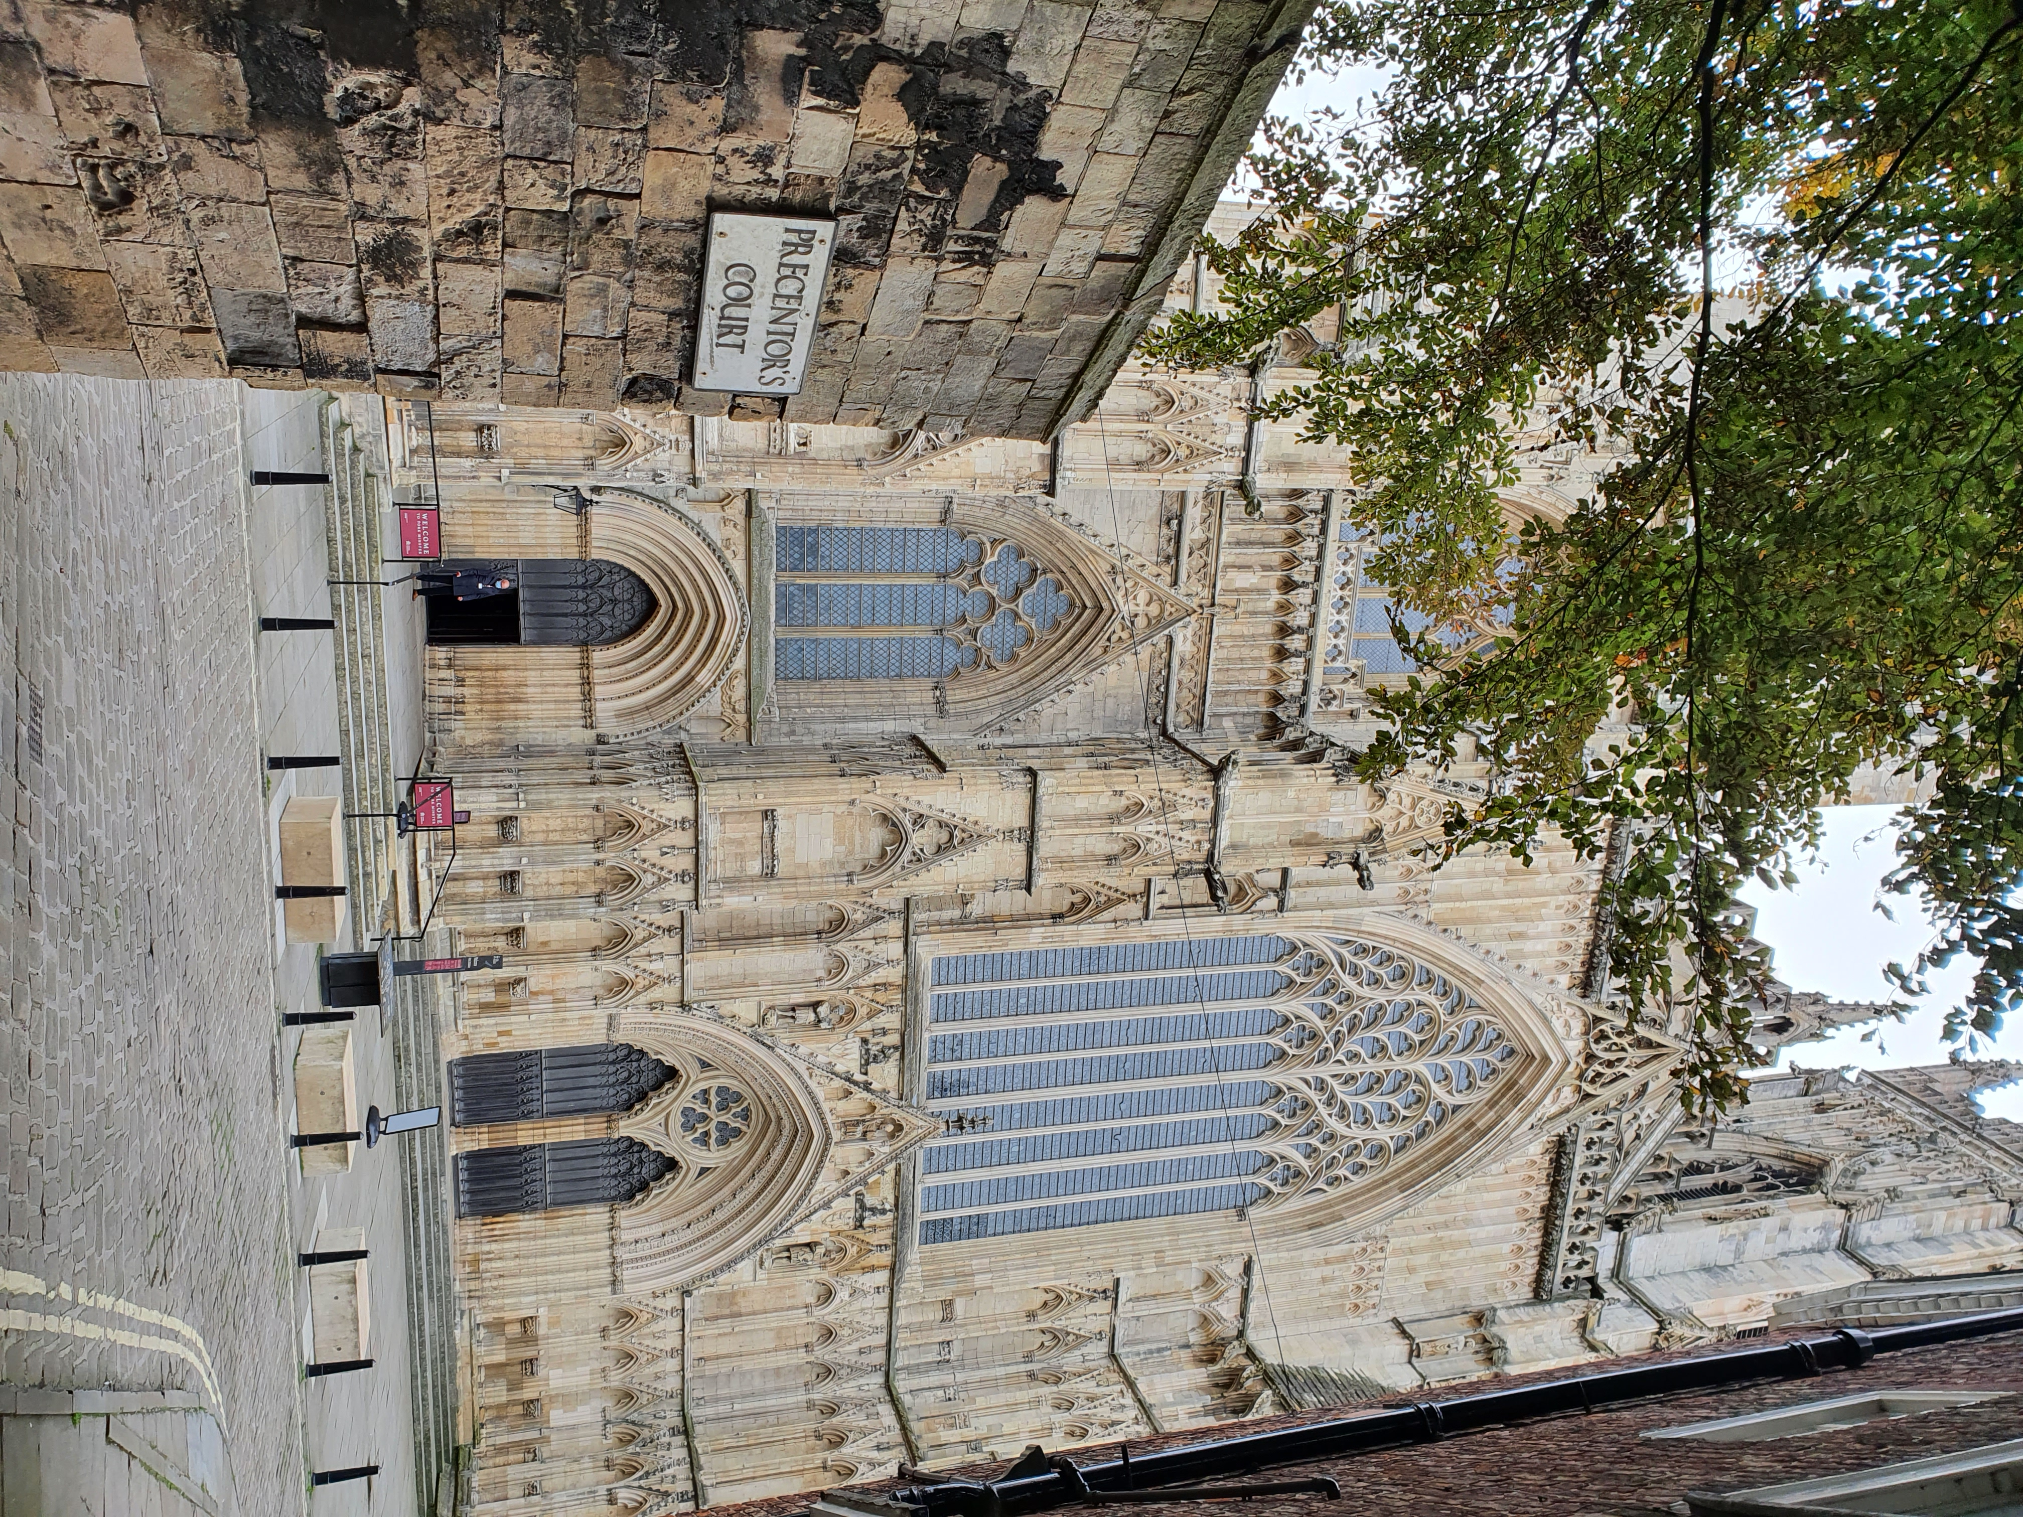45 Minutes / 2 Miles (3.2 km)

As of May 2021
Please check before travelling

